Edge-Based Smart Classroom Environmental and Occupancy Monitoring System
Bugero, Carl James
Gonzales, Icon Zeus
Legaspi, Elizabeth
Panganiban, Larissa Eunice
Vencilao, Johara Karylle
BSIT - 4D

ABSTRACT
This project presents an edge-based classroom environmental and occupancy monitoring system using an ESP32 DevKit V1, a DHT11 temperature and humidity sensor, and an HC-SR501 passive infrared motion sensor. The ESP32 performs temperature classification, motion monitoring, occupancy estimation, and LED control locally. Programmed temperature categories are normal at T ≤ 32°C, warning at 32°C < T ≤ 35°C, and danger at T > 35°C. Humidity is monitored but does not trigger these classifications. Motion sets the occupancy estimate to “Likely occupied” and renews a ten-minute inactivity timer. Ten minutes without detected motion produces “No recent activity”; a restart begins with “Unknown.” These estimates do not establish occupant counts or confirmed vacancy. Authenticated HTTPS uploads store readings and transitions in Firebase Realtime Database. A web dashboard displays current conditions, historical records, alerts, and device status. Stale or unavailable telemetry produces an unknown current occupancy estimate. Local monitoring continues during network interruptions, although pending events in volatile memory may be lost during power failure. Software checks passed for occupancy timing, application logic, database rules, website build, and firmware compilation. Existing prototype records demonstrate environmental and motion functions, but contain a warning-test inconsistency requiring retesting. Physical validation of the new occupancy behavior remains pending.
Keywords: ESP32, edge computing, environmental monitoring, motion-based occupancy estimation, Firebase, smart classroom.

INTRODUCTION
This project monitors classroom temperature, relative humidity, and recent activity without collecting images. A connected dashboard makes current readings and retained records available through a common interface.
The ESP32 performs temperature classification, occupancy timing, and LED control locally. Firebase supplies authentication and storage, and the website presents device-reported information. Cloud access is required for remote updates, but not local monitoring decisions.
A PIR sensor responds to changes in infrared radiation associated with movement [1]. Its output does not identify people or establish how many are present. The project therefore distinguishes current motion, recorded detection events, and a timed occupancy estimate. Stationary occupants can be missed, and a no-recent-activity estimate does not confirm that the classroom is empty.

Objectives
1. Integrate the DHT11 and HC-SR501 sensors with the ESP32 DevKit V1.
2. Classify temperature readings and control local LED indicators using predefined thresholds.
3. Estimate occupancy locally using motion and a ten-minute inactivity timeout.
4. Keep current motion, detection-event counts, and occupancy estimates separate.
5. Store current readings, historical snapshots, and transitions through authenticated HTTPS communication.
6. Provide an authenticated dashboard with environmental readings, occupancy estimates, alerts, historical analysis, and device information.
7. Continue local monitoring during network interruptions and identify stale remote readings.

SYSTEM DESIGN
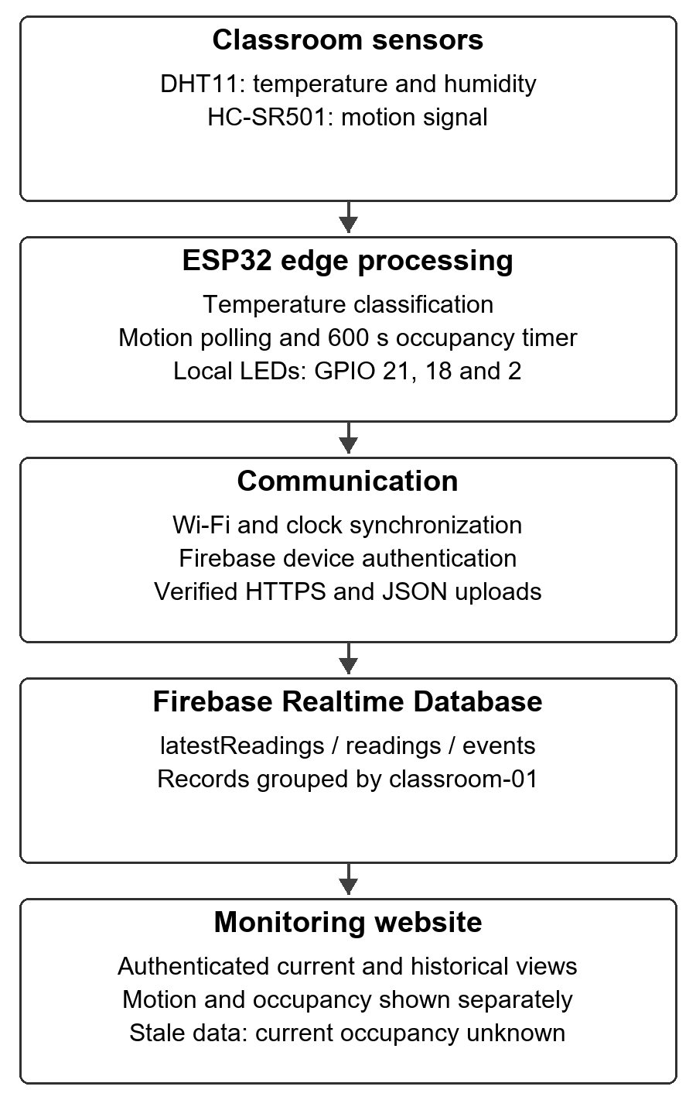
Figure 4.1. System architecture and data flow
Figure 4.1 shows the classroom sensors, ESP32 edge processing, communication and authentication, cloud database, and monitoring website. The ESP32 reads the DHT11 and PIR, evaluates temperature conditions, maintains the occupancy timer, and controls the LEDs. FreeRTOS tasks and queues separate monitoring from network operations; the ESP32 platform provides the task facilities used by the firmware [3].
The uploader authenticates with Firebase and transmits JSON records over certificate-verified HTTPS. Firebase documents email/password authentication, token renewal, and database REST writes [4], [5]. The website reads stored records after sign-in and applies freshness checks before displaying current device and occupancy status.
Table 4.1. System interconnection and data flow
Connection | Purpose
DHT11 to ESP32 | Temperature and relative humidity input on GPIO 4.
HC-SR501 to ESP32 | Digital motion input on GPIO 34; input to occupancy estimation.
ESP32 to green / red LEDs | GPIO 21 indicates normal temperature; GPIO 18 indicates warning or danger.
ESP32 to built-in LED | GPIO 2 follows the current PIR signal, not the occupancy timeout.
ESP32 to Serial Monitor | 115200-baud readings, transition logs, and operational messages.
ESP32 to Firebase services | Wi-Fi, authentication, time synchronization, and HTTPS record uploads.
Firebase to website | Authenticated access to current readings, historical snapshots, and events.

Hardware Components and Supporting Services
Table 4.2. Components and services
Component or service | Function
ESP32 DevKit V1 and USB cable | Controller, local processing, programming, power, and serial communication.
DHT11 sensor | Temperature and relative humidity measurements.
HC-SR501 PIR sensor | Motion signal within the sensor coverage area.
Breadboard and jumper wires | Prototype connections and common ground.
Green LED and 220 Ω resistor | Normal temperature indication.
Red LED and 220 Ω resistor | Warning: toggles every 300 ms. Danger: continuously on.
Built-in LED on GPIO 2 | Current motion indication.
Wi-Fi network | Connectivity to cloud services.
Firebase Authentication and Realtime Database | Account authentication and record storage.
Web dashboard | Remote presentation and historical review.

Wiring and Hardware Connections
The DHT11 module positive pin is connected to 3V3, its negative pin to GND, and its signal pin to GPIO 4. The HC-SR501 VCC pin is connected to VIN, GND to the common ground, and OUT to GPIO 34. The green LED is connected to GPIO 21 through a 220 Ω current-limiting resistor, and the red LED to GPIO 18 through a 220 Ω resistor. The built-in LED uses GPIO 2. All components share the ESP32 ground.

System Processing and Data Transmission
The DHT11 is sampled every two seconds while the main loop repeatedly polls the PIR input. A separate network task handles cloud communication. The newest snapshot is queued approximately every five seconds and when motion or occupancy changes. Valid environmental history is uploaded at most once per minute when communication succeeds. Motion, temperature, and occupancy transitions are recorded separately.
Table 4.3. Database record groups
Database path | Stored information
latestReadings/classroom-01 | Newest available readings, sensor status, LED reports, and occupancy estimate.
readings/classroom-01 | Historical environmental snapshots with their motion and occupancy states.
events/classroom-01 | Motion transitions, temperature classifications, and occupancy transitions.
New readings include occupancyStatus and occupancyTimeoutSeconds, with a timeout of 600 seconds. The occupancy transition types are occupancy_likely_occupied, occupancy_no_recent_activity, and occupancy_unknown. These events do not increase the motion-detection count. Server timestamps indicate record arrival, while available device timestamps preserve sample or event occurrence time.

Occupancy States and Design Settings
Table 4.4. Motion-based occupancy state transitions
Condition | Estimate and meaning
Restart before motion or a full initial observation interval | Unknown: insufficient activity evidence since restart.
PIR HIGH or activity within the previous ten minutes | Likely occupied: recent detected activity, not an occupant count.
Full ten-minute interval without motion | No recent activity: vacancy is not confirmed.
Stale telemetry or unavailable database connection | Unknown on website: current occupancy cannot be established.
The ten-minute inactivity timeout is an initial prototype setting. It allows the estimate to persist during short periods without detected movement, but has not been optimized through comparative classroom trials. The 32°C and 35°C temperature thresholds are programmed project categories, not certified comfort or health limits. Humidity is displayed without separate alert thresholds.

BUILD AND IMPLEMENTATION

5.1 Hardware Assembly and Circuit Wiring
The ESP32 and sensors were assembled on a solderless breadboard using the connections described in System Design. USB supplies power and provides the 115200-baud Serial Monitor connection. External LEDs use current-limiting resistors, and the built-in LED supplies the local motion indication.

5.2 Development Tools and Libraries
Arduino IDE and the ESP32 board package support firmware development and compilation. The Adafruit DHT Sensor Library reads the DHT11; ArduinoJson handles JSON data. ESP32 Wi-Fi and secure HTTP libraries provide network communication, while FreeRTOS tasks and queues separate monitoring from uploads.
The dashboard uses Next.js, React, and TypeScript. Firebase Authentication supplies sign-in, Firebase Realtime Database provides live subscriptions and retained records, and Recharts displays environmental history. The Serial Monitor provides local readings and diagnostics; the website provides remote access.

5.3 Hardware Limitations and Implementation Workarounds
An active buzzer was unavailable, so local alerts were implemented using the red LED. Warning conditions toggle the LED every 300 ms, while danger conditions keep it on. The built-in LED on GPIO 2 indicates the PIR signal without adding another external LED.
The prototype has no local numerical display. Readings are available through the Serial Monitor and dashboard. Remote updates require connectivity, while sensing, temperature classification, occupancy timing, and LED control operate locally.
The PIR cannot count people or consistently establish stationary presence. The inactivity timeout reduces immediate changes after movement stops, but does not eliminate missed occupancy. Manufacturer specifications also limit environmental measurement precision; the DHT11 datasheet reports nominal tolerances of ±2°C and ±5% relative humidity [2]. These specifications are not measurements of this assembled prototype’s accuracy.

HOW THE SYSTEM WORKS

6.1 Firmware Logic and Execution Loop

Initialization
The ESP32 starts serial communication, configures the input and output pins, initializes the DHT11 and queues, and starts Wi-Fi and clock synchronization. Occupancy begins as unknown and an initial event is queued. A separate uploader task handles cloud communication.
The firmware reports a PIR warm-up requirement but does not implement a fixed 30–60-second blocking pause. PIR sensors can exhibit unstable output during stabilization [1]. Initial detections must therefore be treated cautiously during physical evaluation.

Motion Monitoring
GPIO 34 is repeatedly polled. HIGH turns the motion LED on; LOW turns it off. Changes generate motion-started or motion-stopped events. One person may produce multiple rising edges, so recorded detections are not a count of occupants.

Occupancy Estimation
Each HIGH PIR reading sets the estimate to likely occupied and renews the last-activity time. When the PIR becomes LOW, the estimate remains likely occupied until the full ten-minute inactivity interval has elapsed. The estimate then becomes no recent activity. Before any motion after restart, it remains unknown until a full initial ten-minute observation window has elapsed.
Continuous or repeated motion renews the timer without creating duplicate occupancy transitions while the state remains unchanged. The calculation uses elapsed time from the ESP32 millisecond clock and continues without Wi-Fi.

Environmental Monitoring and LED Control
Every two seconds, the ESP32 reads temperature and humidity. Valid readings update the measurements. At T ≤ 32°C, green is on and red is off. At 32°C < T ≤ 35°C, green is off and red toggles every 300 ms. At T > 35°C, green is off and red remains on. LED timing is handled separately from the DHT sampling interval.
Failed or out-of-range DHT readings set the sensor-error flag. Invalid temperature and humidity values are omitted from uploaded snapshots, and invalid environmental history is not saved. Temperature LEDs retain the previous valid temperature condition; before the first valid reading, both are off. Motion and occupancy updates continue independently.

Cloud Uploading and Record Storage
The uploader task performs authentication, token renewal, and HTTPS requests. A one-slot latest-reading queue keeps the newest snapshot, and a bounded event queue holds pending transitions. Network requests are not executed directly inside the main sensor loop.
Successfully uploaded historical records remain in Firebase after the device is turned off, subject to access permissions and retention. Pending events are held in volatile memory and may be lost during power failure or dropped if the queue fills. Remote delivery is therefore not guaranteed for every offline event.

Website Monitoring
The website shows the device-reported occupancy estimate separately from current motion. A likely-occupied estimate can coexist with an idle PIR signal. History tables and CSV exports retain the occupancy state stored with each sample; old samples without occupancy fields remain unknown.
The last recorded motion detection remains visible when the device goes offline. Current device status uses the age of server-stamped telemetry, with a default freshness timeout of 30 seconds. The displayed state changes at the configured refresh interval. Stale readings produce offline device status and unknown current occupancy. Browser database disconnection produces unavailable connection status rather than independently proving that the ESP32 is offline.

6.2 System Logic Flowchart
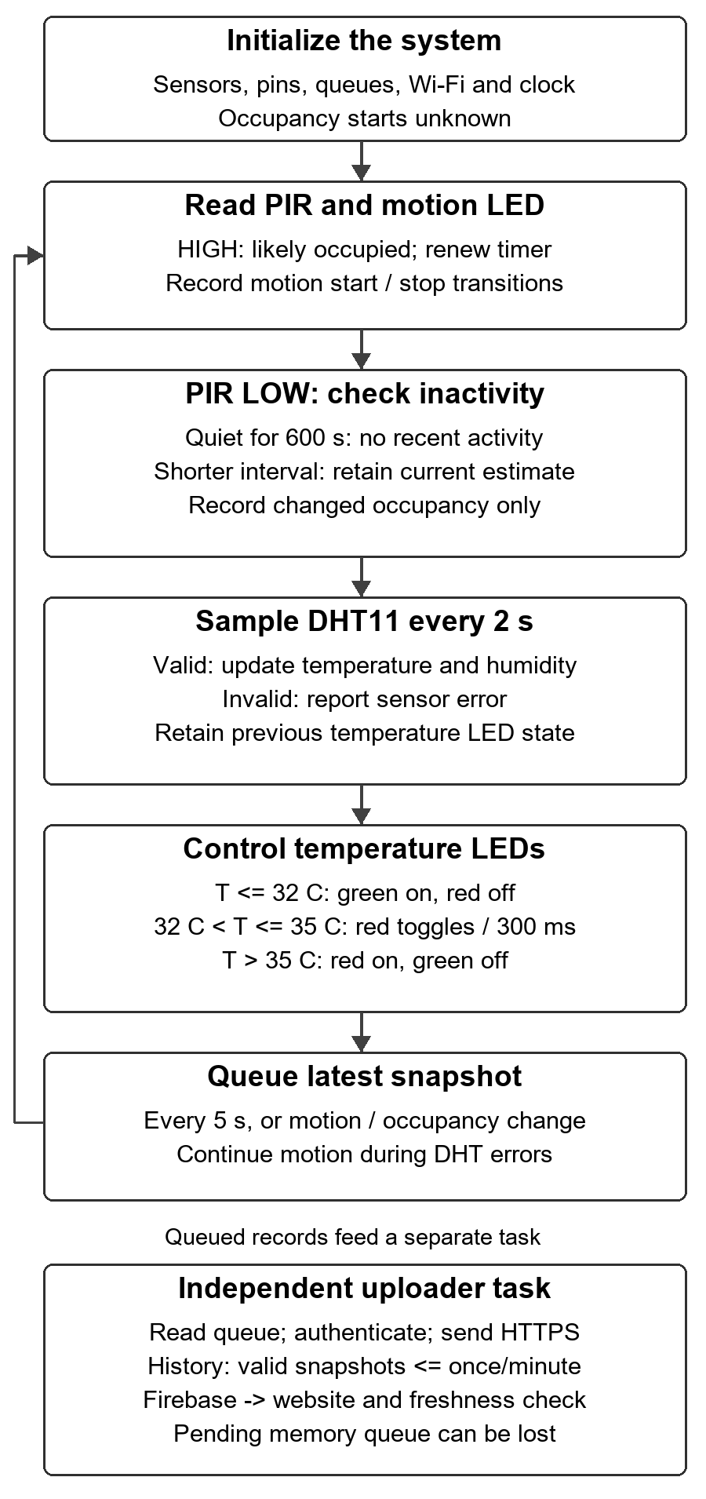
Figure 6.1. Local monitoring loop and independent uploader task
The monitoring loop updates motion and occupancy, samples the DHT11 on its timer, applies the temperature LED behavior, and queues snapshots. Occupancy changes only on a state transition. A separate uploader task sends records when network and authentication conditions permit. A sensor error does not stop motion or occupancy processing.

TESTING AND RESULTS

7.1 Existing Environmental and Motion Records
The original prototype records include breadboard photographs, Serial Monitor output, and six functional-test entries reproduced in Appendix E. They document environmental readings and motion responses, but do not establish measured performance for the new occupancy timer.
The original procedure used localized breath testing to observe changes in sensor output. This is a functional response check, not a calibration or accuracy test. The supplied records do not identify a reference instrument, total observation duration, repeated-trial count, or complete PIR placement and adjustment settings. Conclusions are limited accordingly.
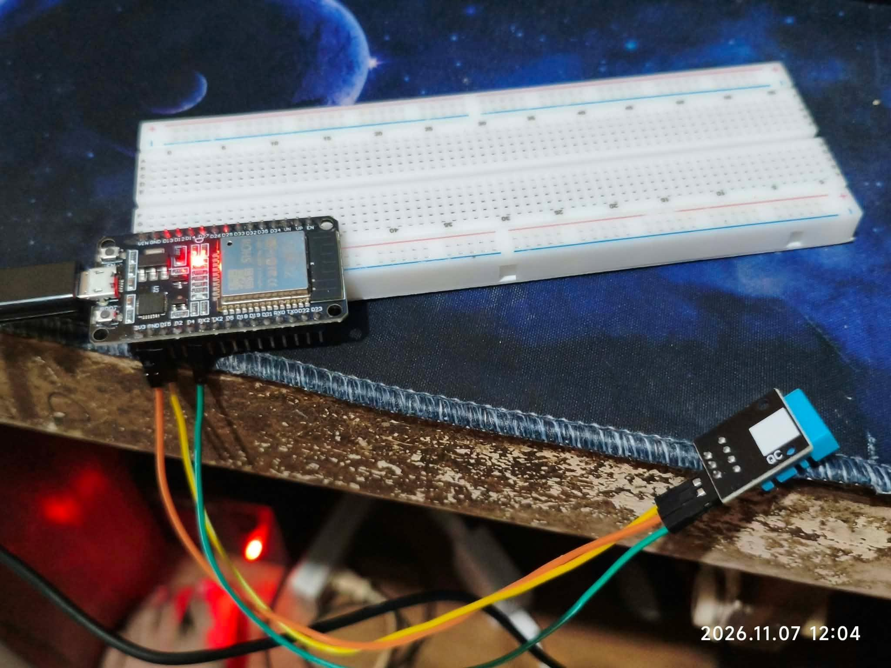
Figure 7.1. Prototype used for environmental response checks
The photograph shows the DHT11 and ESP32 arrangement used with USB power and Serial Monitor logging. The reported readings provide examples of operation; the photograph does not independently establish measurement accuracy.
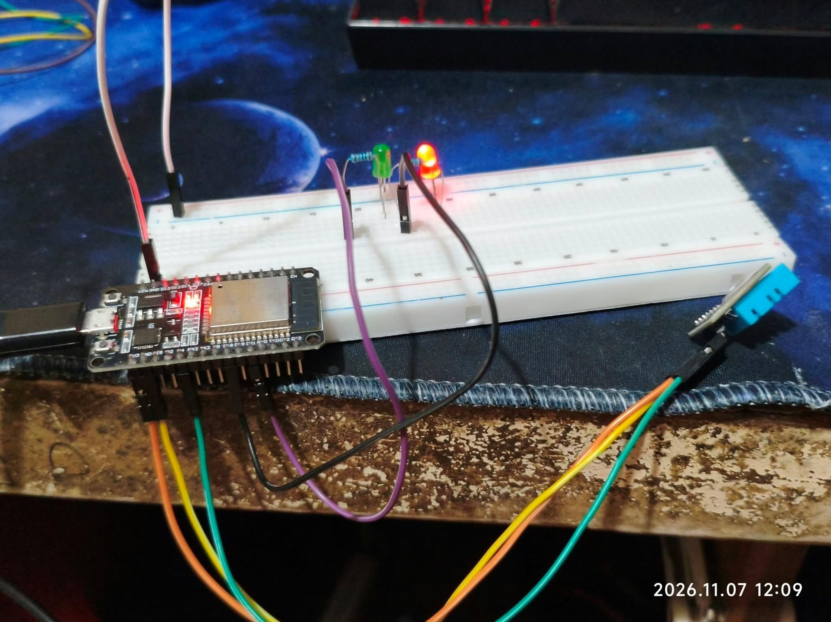
Figure 7.2. DHT11 prototype with LED indicators
LED behavior is determined by temperature only: normal at T ≤ 32°C, warning at 32°C < T ≤ 35°C, and danger at T > 35°C. Relative humidity is recorded but does not trigger these modes. A still photograph cannot distinguish blinking from continuous illumination without supporting logs or observations.
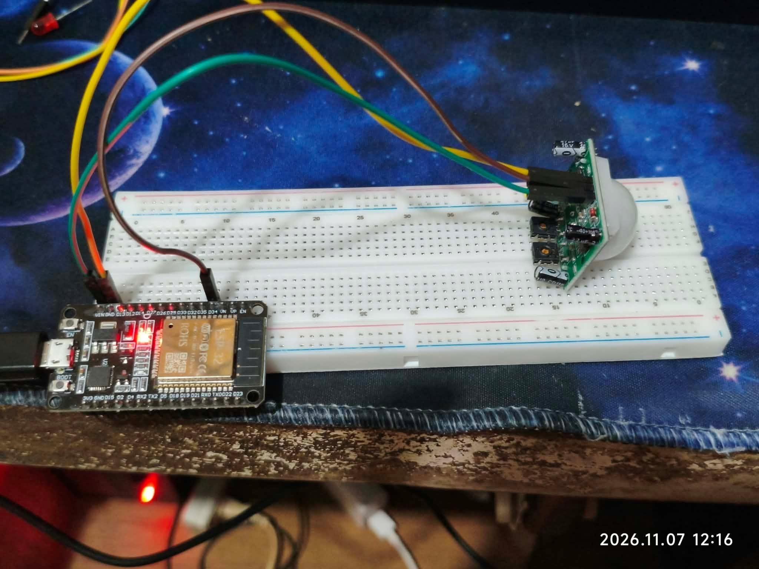
Figure 7.3. PIR motion-sensor test arrangement
The HC-SR501 output is connected to GPIO 34. Its signal drives the GPIO 2 motion LED and produces motion-transition messages. This verifies the type of signal used by occupancy estimation, but does not demonstrate a ten-minute occupancy transition or confirmed stationary presence.

7.2 Software Verification
During the occupancy update, type checking, linting, and the production website build passed. Six application logic tests and thirteen Firebase database-rule tests passed. Compile-time assertions checked the shared occupancy state machine, and both the active Downloads sketch and repository firmware compiled successfully.
The occupancy assertions cover startup, the exact 600-second boundary, repeated motion, continuous HIGH input, unchanged states, and millisecond-clock rollover. Application tests verify unknown occupancy for stale, missing, or invalid fields. Database tests check valid occupancy records and rejection of invalid combinations. These checks verify the tested software configuration, not classroom sensing accuracy or deployment of the same rules to the live database.
An authenticated dashboard inspection confirmed that the occupancy panel displayed correctly and that older firmware records without occupancy fields showed unknown. This inspection did not verify a physical occupancy transition from the updated firmware.

7.3 Physical Occupancy Validation
Physical validation of the updated occupancy feature remains pending. Appendix E separates planned acceptance tests from existing observations. Each new trial should record the firmware version or test date, sensor placement and settings, observed motion signal, device transition time, Firebase record, and dashboard state.
Tests should include a full ten-minute quiet interval, repeated movement before expiry, continuous motion output, a stationary occupant, DHT failure, restart, Wi-Fi interruption, and power removal. Transition timing should be measured from the last HIGH PIR signal, rather than from the instant a person subjectively stops moving. No occupancy accuracy rate or false-trigger rate is claimed without ground-truth observations and repeated trials.

DISCUSSION AND OUTCOME
The system extends the original prototype with local occupancy timing, authenticated storage, and remote monitoring. Edge processing is established by performing temperature decisions, occupancy estimation, and LED control on the ESP32. The cloud supports storage and presentation.
The ten-minute window preserves the occupancy estimate during short quiet intervals, but stationary occupants can still be missed. No recent activity does not confirm vacancy. The timeout and temperature thresholds remain prototype settings requiring classroom evaluation. Environmental readings describe the sensor location, not necessarily the whole room.
Camera-free sensing avoids collecting images, but activity timestamps can reveal usage patterns and require access controls. Uploaded history persists separately from current status; volatile pending records may be lost during power failure.
The original warning test reports 35.2°C with a blinking LED, conflicting with the danger threshold above 35°C. It requires retesting. The sensor-disconnect test also requires verification against the updated firmware. Original observations are retained, while their result interpretations are corrected.
Software checks do not establish occupancy accuracy or complete physical validation. Future evaluation should address PIR placement, timeout selection, stationary-presence sensing, and durable event storage. A local display and audible alerts may also be considered.

CONCLUSION
The ESP32 prototype performs environmental monitoring, motion-based occupancy estimation, and LED control locally. Firebase and an authenticated dashboard provide remote readings, events, and historical access. The ten-minute estimate reports likely occupied, no recent activity, or unknown; it does not establish attendance, occupant counts, or confirmed vacancy.
Software verification and firmware compilation passed. Physical occupancy validation remains pending. The inconsistent warning result and updated sensor-error behavior require retesting before complete functional validation can be claimed.

REFERENCES
[1] Adafruit. (n.d.). PIR motion sensor: Overview and using a PIR with Arduino. Adafruit Learning System.
https://learn.adafruit.com/pir-passive-infrared-proximity-motion-sensor/overview
https://learn.adafruit.com/pir-passive-infrared-proximity-motion-sensor/using-a-pir-w-arduino
Accessed November 11, 2026.
[2] Guangzhou Aosong Electronics Co., Ltd. (n.d.). DHT11 digital temperature and humidity sensor [Datasheet, Chinese-language edition]. Hosted by Adafruit.
https://cdn-shop.adafruit.com/datasheets/DHT11-chinese.pdf
Accessed November 11, 2026.
[3] Espressif Systems. (n.d.). FreeRTOS (IDF). ESP-IDF Programming Guide.
https://docs.espressif.com/projects/esp-idf/en/stable/esp32/api-reference/system/freertos_idf.html
Accessed November 11, 2026.
[4] Google. (n.d.). Firebase Auth REST API. Firebase documentation.
https://firebase.google.com/docs/reference/rest/auth
Accessed November 11, 2026.
[5] Google. (n.d.). Saving data. Firebase Realtime Database documentation.
https://firebase.google.com/docs/database/rest/save-data
Accessed November 11, 2026.

APPENDICES

Appendix A Arduino Source Code
The following listing reproduces the updated Downloads sketch and its accompanying occupancy.h file. Wi-Fi and Firebase configuration strings are redacted for submission. Certificate data are public trust material. The listing documents the implemented firmware; it does not establish that this version has been uploaded to the physical device.

A1 Main Arduino Sketch
File: SmartClassroom.ino
#include <WiFi.h>
#include <WiFiClientSecure.h>
#include <HTTPClient.h>
#include <ArduinoJson.h>
#include <DHT.h>
#include "occupancy.h"
#include <time.h>
#include <esp_system.h>
#include "freertos/FreeRTOS.h"
#include "freertos/task.h"
#include "freertos/queue.h"

// ==== LOCAL ONLY ====
const char* WIFI_SSID = "REDACTED";
const char* WIFI_PASSWORD = "REDACTED";
const char* FIREBASE_API_KEY = "REDACTED";
const char* DEVICE_EMAIL = "REDACTED";
const char* DEVICE_PASSWORD = "REDACTED";
// Full Realtime Database URL
const char* DATABASE_URL = "REDACTED";
const char* DEVICE_ID = "classroom-01";
extern const uint8_t x509_crt_bundle_start[] asm("_binary_x509_crt_bundle_start");
extern const uint8_t x509_crt_bundle_end[] asm("_binary_x509_crt_bundle_end");

// Public CA roots (not secrets). Verify current Google/Firebase trust chain
// before deploying; update this trust bundle when CA chains change.
static const char TRUSTED_ROOTS[] = R"CERT(
-----BEGIN CERTIFICATE-----
MIIFVzCCAz+gAwIBAgINAgPlk28xsBNJiGuiFzANBgkqhkiG9w0BAQwFADBHMQsw
CQYDVQQGEwJVUzEiMCAGA1UEChMZR29vZ2xlIFRydXN0IFNlcnZpY2VzIExMQzEU
MBIGA1UEAxMLR1RTIFJvb3QgUjEwHhcNMTYwNjIyMDAwMDAwWhcNMzYwNjIyMDAw
MDAwWjBHMQswCQYDVQQGEwJVUzEiMCAGA1UEChMZR29vZ2xlIFRydXN0IFNlcnZp
Y2VzIExMQzEUMBIGA1UEAxMLR1RTIFJvb3QgUjEwggIiMA0GCSqGSIb3DQEBAQUA
A4ICDwAwggIKAoICAQC2EQKLHuOhd5s73L+UPreVp0A8of2C+X0yBoJx9vaMf/vo
27xqLpeXo4xL+Sv2sfnOhB2x+cWX3u+58qPpvBKJXqeqUqv4IyfLpLGcY9vXmX7w
Cl7raKb0xlpHDU0QM+NOsROjyBhsS+z8CZDfnWQpJSMHobTSPS5g4M/SCYe7zUjw
TcLCeoiKu7rPWRnWr4+wB7CeMfGCwcDfLqZtbBkOtdh+JhpFAz2weaSUKK0Pfybl
qAj+lug8aJRT7oM6iCsVlgmy4HqMLnXWnOunVmSPlk9orj2XwoSPwLxAwAtcvfaH
szVsrBhQf4TgTM2S0yDpM7xSma8ytSmzJSq0SPly4cpk9+aCEI3oncKKiPo4Zor8
Y/kB+Xj9e1x3+naH+uzfsQ55lVe0vSbv1gHR6xYKu44LtcXFilWr06zqkUspzBmk
MiVOKvFlRNACzqrOSbTqn3yDsEB750Orp2yjj32JgfpMpf/VjsPOS+C12LOORc92
wO1AK/1TD7Cn1TsNsYqiA94xrcx36m97PtbfkSIS5r762DL8EGMUUXLeXdYWk70p
aDPvOmbsB4om3xPXV2V4J95eSRQAogB/mqghtqmxlbCluQ0WEdrHbEg8QOB+DVrN
VjzRlwW5y0vtOUucxD/SVRNuJLDWcfr0wbrM7Rv1/oFB2ACYPTrIrnqYNxgFlQID
AQABo0IwQDAOBgNVHQ8BAf8EBAMCAYYwDwYDVR0TAQH/BAUwAwEB/zAdBgNVHQ4E
FgQU5K8rJnEaK0gnhS9SZizv8IkTcT4wDQYJKoZIhvcNAQEMBQADggIBAJ+qQibb
C5u+/x6Wki4+omVKapi6Ist9wTrYggoGxval3sBOh2Z5ofmmWJyq+bXmYOfg6LEe
QkEzCzc9zolwFcq1JKjPa7XSQCGYzyI0zzvFIoTgxQ6KfF2I5DUkzps+GlQebtuy
h6f88/qBVRRiClmpIgUxPoLW7ttXNLwzldMXG+gnoot7TiYaelpkttGsN/H9oPM4
7HLwEXWdyzRSjeZ2axfG34arJ45JK3VmgRAhpuo+9K4l/3wV3s6MJT/KYnAK9y8J
ZgfIPxz88NtFMN9iiMG1D53Dn0reWVlHxYciNuaCp+0KueIHoI17eko8cdLiA6Ef
MgfdG+RCzgwARWGAtQsgWSl4vflVy2PFPEz0tv/bal8xa5meLMFrUKTX5hgUvYU/
Z6tGn6D/Qqc6f1zLXbBwHSs09dR2CQzreExZBfMzQsNhFRAbd03OIozUhfJFfbdT
6u9AWpQKXCBfTkBdYiJ23//OYb2MI3jSNwLgjt7RETeJ9r/tSQdirpLsQBqvFAnZ
0E6yove+7u7Y/9waLd64NnHi/Hm3lCXRSHNboTXns5lndcEZOitHTtNCjv0xyBZm
2tIMPNuzjsmhDYAPexZ3FL//2wmUspO8IFgV6dtxQ/PeEMMA3KgqlbbC1j+Qa3bb
bP6MvPJwNQzcmRk13NfIRmPVNnGuV/u3gm3c
-----END CERTIFICATE-----
-----BEGIN CERTIFICATE-----
MIIFazCCA1OgAwIBAgIRAIIQz7DSQONZRGPgu2OCiwAwDQYJKoZIhvcNAQELBQAw
TzELMAkGA1UEBhMCVVMxKTAnBgNVBAoTIEludGVybmV0IFNlY3VyaXR5IFJlc2Vh
cmNoIEdyb3VwMRUwEwYDVQQDEwxJU1JHIFJvb3QgWDEwHhcNMTUwNjA0MTEwNDM4
WhcNMzUwNjA0MTEwNDM4WjBPMQswCQYDVQQGEwJVUzEpMCcGA1UEChMgSW50ZXJu
ZXQgU2VjdXJpdHkgUmVzZWFyY2ggR3JvdXAxFTATBgNVBAMTDElTUkcgUm9vdCBY
MTCCAiIwDQYJKoZIhvcNAQEBBQADggIPADCCAgoCggIBAK3oJHP0FDfzm54rVygc
h77ct984kIxuPOZXoHj3dcKi/vVqbvYATyjb3miGbESTtrFj/RQSa78f0uoxmyF+
0TM8ukj13Xnfs7j/EvEhmkvBioZxaUpmZmyPfjxwv60pIgbz5MDmgK7iS4+3mX6U
A5/TR5d8mUgjU+g4rk8Kb4Mu0UlXjIB0ttov0DiNewNwIRt18jA8+o+u3dpjq+sW
T8KOEUt+zwvo/7V3LvSye0rgTBIlDHCNAymg4VMk7BPZ7hm/ELNKjD+Jo2FR3qyH
B5T0Y3HsLuJvW5iB4YlcNHlsdu87kGJ55tukmi8mxdAQ4Q7e2RCOFvu396j3x+UC
B5iPNgiV5+I3lg02dZ77DnKxHZu8A/lJBdiB3QW0KtZB6awBdpUKD9jf1b0SHzUv
KBds0pjBqAlkd25HN7rOrFleaJ1/ctaJxQZBKT5ZPt0m9STJEadao0xAH0ahmbWn
OlFuhjuefXKnEgV4We0+UXgVCwOPjdAvBbI+e0ocS3MFEvzG6uBQE3xDk3SzynTn
jh8BCNAw1FtxNrQHusEwMFxIt4I7mKZ9YIqioymCzLq9gwQbooMDQaHWBfEbwrbw
qHyGO0aoSCqI3Haadr8faqU9GY/rOPNk3sgrDQoo//fb4hVC1CLQJ13hef4Y53CI
rU7m2Ys6xt0nUW7/vGT1M0NPAgMBAAGjQjBAMA4GA1UdDwEB/wQEAwIBBjAPBgNV
HRMBAf8EBTADAQH/MB0GA1UdDgQWBBR5tFnme7bl5AFzgAiIyBpY9umbbjANBgkq
hkiG9w0BAQsFAAOCAgEAVR9YqbyyqFDQDLHYGmkgJykIrGF1XIpu+ILlaS/V9lZL
ubhzEFnTIZd+50xx+7LSYK05qAvqFyFWhfFQDlnrzuBZ6brJFe+GnY+EgPbk6ZGQ
3BebYhtF8GaV0nxvwuo77x/Py9auJ/GpsMiu/X1+mvoiBOv/2X/qkSsisRcOj/KK
NFtY2PwByVS5uCbMiogziUwthDyC3+6WVwW6LLv3xLfHTjuCvjHIInNzktHCgKQ5
ORAzI4JMPJ+GslWYHb4phowim57iaztXOoJwTdwJx4nLCgdNbOhdjsnvzqvHu7Ur
TkXWStAmzOVyyghqpZXjFaH3pO3JLF+l+/+sKAIuvtd7u+Nxe5AW0wdeRlN8NwdC
jNPElpzVmbUq4JUagEiuTDkHzsxHpFKVK7q4+63SM1N95R1NbdWhscdCb+ZAJzVc
oyi3B43njTOQ5yOf+1CceWxG1bQVs5ZufpsMljq4Ui0/1lvh+wjChP4kqKOJ2qxq
4RgqsahDYVvTH9w7jXbyLeiNdd8XM2w9U/t7y0Ff/9yi0GE44Za4rF2LN9d11TPA
mRGunUHBcnWEvgJBQl9nJEiU0Zsnvgc/ubhPgXRR4Xq37Z0j4r7g1SgEEzwxA57d
emyPxgcYxn/eR44/KJ4EBs+lVDR3veyJm+kXQ99b21/+jh5Xos1AnX5iItreGCc=
-----END CERTIFICATE-----
)CERT";

#define DHTPIN 4
#define DHTTYPE DHT11
#define PIR_PIN 34
#define RED_LED 18
#define GREEN_LED 21
#define MOTION_LED 2

const float WARN_TEMP = 32.0f;
const float DANGER_TEMP = 35.0f;
const uint32_t DHT_INTERVAL = 2000;
const uint32_t BLINK_INTERVAL = 300;
const uint32_t WIFI_RETRY_INTERVAL = 10000;
const uint32_t SNAPSHOT_INTERVAL = 5000;
const uint32_t HISTORY_INTERVAL = 60000;
const uint32_t AUTH_RETRY_INTERVAL = 15000;

DHT dht(DHTPIN, DHTTYPE);

struct Reading {
float temp;
float humidity;
bool motion;
bool green;
bool red;
bool redBlinking;
bool motionLed;
uint64_t sampledAt;
uint8_t occupancy;
bool sensorError;
};
struct Event {
char id[48];
char type[32];

float temp;
bool hasTemp;
uint64_t timestamp;
uint32_t uptime;
};

QueueHandle_t latestQueue = nullptr; // 1 slot: always newest snapshot
QueueHandle_t eventQueue = nullptr; // 32 slots: FIFO transitions
volatile uint32_t droppedEvents = 0;
uint32_t bootId = 0;
uint32_t eventSequence = 0;

uint32_t lastDht = 0, lastBlink = 0, lastWiFiRetry = 0;
uint32_t lastSnapshot = 0;
bool lastMotion = false, motionInitialized = false;
OccupancyMonitor occupancy;
bool redState = false;
float temperature = NAN, humidity = NAN;
bool dhtError = true;
char previousTempStatus[16] = "";

// Only the network task accesses these auth variables.
String idToken, refreshToken;
uint32_t tokenValidUntil = 0;
uint32_t lastAuthTry = 0;

bool timeReady() { return time(nullptr) > 1735689600; }
uint64_t epochMs() {
struct timeval tv;
gettimeofday(&tv, nullptr);
return (uint64_t)tv.tv_sec * 1000ULL + tv.tv_usec / 1000;
}

const char* tempStatus(float t) {
if (isnan(t)) return "sensor_error";
if (t > DANGER_TEMP) return "danger";
if (t > WARN_TEMP) return "warning";
return "normal";
}

// TLS verification is ON. Never call setInsecure().

bool requestHttps(const String& url,
const char* method,
const String& body,
String& reply,
int& code,
const char* mime = "application/json") {

code = -100;
reply = "";

if (WiFi.status() != WL_CONNECTED) {
Serial.println("[HTTPS] WiFi not connected");
return false;
}

if (!timeReady()) {
Serial.println("[HTTPS] Clock not synchronized");
return false;
}

// Persistent objects: only the uploader task calls this function,
// so static is safe here.
static WiFiClientSecure client;
static HTTPClient http;
static String lastHost = "";
static bool inited = false;

if (!inited) {
client.setCACertBundle(x509_crt_bundle_start,
x509_crt_bundle_end - x509_crt_bundle_start);
client.setTimeout(10000);
http.setReuse(true);
inited = true;
}

http.setTimeout(10000);
http.setConnectTimeout(10000);
http.setFollowRedirects(HTTPC_STRICT_FOLLOW_REDIRECTS);

// Log host without printing API keys or tokens.
int hostStart = url.indexOf("://");
hostStart = hostStart < 0 ? 0 : hostStart + 3;

int hostEnd = url.indexOf('/', hostStart);
if (hostEnd < 0) hostEnd = url.length();

String host = url.substring(hostStart, hostEnd);

// Different server than last time: drop the old connection.
if (host != lastHost) {
client.stop();
lastHost = host;
}

Serial.print("[HTTPS] Connecting to: ");
Serial.println(host);

if (!http.begin(client, url)) {
code = -101;
Serial.println("[HTTPS] http.begin failed");
client.stop();
return false;
}

http.addHeader("Content-Type", mime);

if (!strcmp(method, "POST")) {
code = http.POST(body);
} else if (!strcmp(method, "PUT")) {
code = http.PUT(body);
} else {
code = -102;
http.end();
return false;
}

if (code < 0) {
Serial.print("[HTTPS] Connection error: ");
Serial.println(HTTPClient::errorToString(code));
char err[128];
client.lastError(err, sizeof(err));
Serial.printf("[TLS] lastError: %s\n", err);
client.stop(); // don't reuse a broken connection
} else {
Serial.print("[HTTPS] HTTP status: ");
Serial.println(code);
}

reply = http.getString();

if (code >= 400) {
Serial.println(reply);
Serial.println("[HTTPS] Server rejected request");
}

http.end(); // with setReuse(true), this keeps the socket open

return code >= 200 && code < 300;
}

bool signIn() {
JsonDocument doc;
doc["email"] = DEVICE_EMAIL;
doc["password"] = DEVICE_PASSWORD;
doc["returnSecureToken"] = true;
String payload, reply;
serializeJson(doc, payload);
int code = 0;
String url = String("https://identitytoolkit.googleapis.com/v1/accounts:signInWithPassword?key=") + FIREBASE_API_KEY;
if (!requestHttps(url, "POST", payload, reply, code)) {
Serial.printf("Firebase sign-in failed: HTTP %d\n", code);
return false;
}
JsonDocument response;
if (deserializeJson(response, reply)) return false;
String token = response["idToken"].as<String>();
String refresh = response["refreshToken"].as<String>();
uint32_t ttl = response["expiresIn"].as<uint32_t>();
if (token.isEmpty() || refresh.isEmpty() || ttl < 1) return false;
idToken = token;
refreshToken = refresh;
tokenValidUntil = millis() + (ttl > 120 ? ttl - 120 : 30) * 1000UL;
Serial.println("Firebase authentication OK");
return true;
}

bool refreshAuth() {
if (refreshToken.isEmpty()) return false;
String url = String("https://securetoken.googleapis.com/v1/token?key=") + FIREBASE_API_KEY;
String body = "grant_type=refresh_token&refresh_token=" + refreshToken;
String reply;
int code = 0;
if (!requestHttps(url, "POST", body, reply, code,
"application/x-www-form-urlencoded")) {
Serial.printf("Token refresh failed: HTTP %d\n", code);
return false;
}
JsonDocument response;
if (deserializeJson(response, reply)) return false;
String token = response["id_token"].as<String>();
String refresh = response["refresh_token"].as<String>();
uint32_t ttl = response["expires_in"].as<uint32_t>();
if (token.isEmpty() || ttl < 1) return false;
idToken = token;
if (!refresh.isEmpty()) refreshToken = refresh;
tokenValidUntil = millis() + (ttl > 120 ? ttl - 120 : 30) * 1000UL;
return true;
}

bool ensureAuth() {
if (WiFi.status() != WL_CONNECTED || !timeReady()) return false;
if (!idToken.isEmpty() && (int32_t)(millis() - tokenValidUntil) < 0) return true;
if (lastAuthTry && millis() - lastAuthTry < AUTH_RETRY_INTERVAL) return false;
lastAuthTry = millis();
if (refreshAuth()) return true;
return signIn();
}

bool writeFirebase(const String& path, const char* method, const String& payload) {
if (!ensureAuth()) return false;
String url = String(DATABASE_URL) + "/" + path + ".json?auth=" + idToken;
String reply;
int code = 0;
bool ok = requestHttps(url, method, payload, reply, code);
if (!ok) {
Serial.printf("Firebase %s failed: HTTP %d\n", path.c_str(), code);
if (code == 401) { idToken = ""; tokenValidUntil = 0; }
}
return ok;
}

String readingJson(const Reading& r) {
JsonDocument doc;
if (!r.sensorError) {
doc["temperature"] = r.temp;
doc["humidity"] = r.humidity;
}
doc["motion"] = r.motion;
doc["sensorError"] = r.sensorError;
doc["temperatureStatus"] = isnan(r.temp) ? "normal" : tempStatus(r.temp);
doc["greenLED"] = r.green;
doc["redLED"] = r.red;
doc["redLEDBlinking"] = r.redBlinking;
doc["motionLED"] = r.motionLed;
doc["occupancyStatus"] = occupancyName(r.occupancy);
doc["occupancyTimeoutSeconds"] = OCCUPANCY_TIMEOUT_SECONDS;
if (r.sampledAt) doc["sampledAt"] = r.sampledAt;
doc["timestamp"][".sv"] = "timestamp";
String out;
serializeJson(doc, out);
return out;
}

String eventJson(const Event& e) {
JsonDocument doc;
doc["type"] = e.type;
if (e.hasTemp) doc["temperature"] = e.temp;
doc["timestamp"] = e.timestamp;
doc["receivedAt"][".sv"] = "timestamp";
String out;
serializeJson(doc, out);
return out;
}

void queueEvent(const char* type) {
if (!eventQueue) return;
Event e = {};
snprintf(e.id, sizeof(e.id), "%08lx-%08lx",
(unsigned long)bootId, (unsigned long)eventSequence++);
snprintf(e.type, sizeof(e.type), "%s", type);

e.hasTemp = !isnan(temperature);
e.temp = temperature;
e.uptime = millis();
e.timestamp = timeReady() ? epochMs() : 0;
if (xQueueSend(eventQueue, &e, 0) != pdTRUE) {
droppedEvents++;
Serial.println("WARNING: Event queue full; event dropped");
}
}

// Network I/O runs only here, never inside loop().
void uploaderTask(void* arg) {
Reading latest = {};
Event pendingEvent = {};
bool haveLatest = false, havePendingEvent = false;
uint32_t lastHistory = 0, lastAttempt = 0;
for (;;) {
Reading incoming;
if (xQueueReceive(latestQueue, &incoming, 0) == pdTRUE) {
latest = incoming;
haveLatest = true;
}
if (!havePendingEvent && xQueueReceive(eventQueue, &pendingEvent, 0) == pdTRUE)
havePendingEvent = true;

if (millis() - lastAttempt >= 1000 && WiFi.status() == WL_CONNECTED && timeReady()) {
lastAttempt = millis();
if (haveLatest) {
String payload = readingJson(latest);
if (writeFirebase(String("latestReadings/") + DEVICE_ID, "PUT", payload)) {
haveLatest = false;
Serial.println("Latest reading uploaded");
// History sampled at most once per minute, with unique path.
if (!latest.sensorError && (lastHistory == 0 || millis() - lastHistory >= HISTORY_INTERVAL)) {
String historyId = String((unsigned long)bootId, HEX) + "-" + String((unsigned long)millis(), HEX);
if (writeFirebase(String("readings/") + DEVICE_ID + "/" + historyId,
"PUT", payload)) lastHistory = millis();
}
}
}
if (havePendingEvent) {
// Fix occurrence time once so retries preserve the same event.
uint64_t nowMs = epochMs();
if (!pendingEvent.timestamp)
pendingEvent.timestamp = nowMs - (uint32_t)(millis() - pendingEvent.uptime);
if (nowMs > pendingEvent.timestamp && nowMs - pendingEvent.timestamp > 86390000ULL) {
Serial.println("Expired queued event discarded (>24h)");
havePendingEvent = false;
continue;
}
if (writeFirebase(String("events/") + DEVICE_ID + "/" + pendingEvent.id,
"PUT", eventJson(pendingEvent))) {
havePendingEvent = false;
Serial.printf("Event uploaded: %s\n", pendingEvent.type);
}
}
}
vTaskDelay(pdMS_TO_TICKS(50));
}
}

void setup() {
Serial.begin(115200);
pinMode(RED_LED, OUTPUT);
pinMode(GREEN_LED, OUTPUT);
pinMode(MOTION_LED, OUTPUT);
pinMode(PIR_PIN, INPUT);
dht.begin();
bootId = esp_random();
latestQueue = xQueueCreate(1, sizeof(Reading));
eventQueue = xQueueCreate(32, sizeof(Event));
if (!latestQueue || !eventQueue) {
Serial.println("FATAL: Queue allocation failed");
while (true) delay(1000);
}
occupancy = OccupancyMonitor(millis());
queueEvent("occupancy_unknown");
WiFi.mode(WIFI_STA);
WiFi.setAutoReconnect(true);
WiFi.begin(WIFI_SSID, WIFI_PASSWORD);
configTime(0, 0, "pool.ntp.org", "time.google.com");
BaseType_t taskResult = xTaskCreatePinnedToCore(
uploaderTask, "FirebaseUploader", 16384, nullptr, 1, nullptr, 0);
if (taskResult != pdPASS) {
Serial.println("FATAL: Uploader task creation failed");
while (true) delay(1000);
}
Serial.println("Smart Classroom ready; PIR warm-up 30-60 sec");
}

void loop() {
uint32_t now = millis();
bool wifiOK = WiFi.status() == WL_CONNECTED;
static bool previousWifi = false;
if (wifiOK != previousWifi) {
Serial.println(wifiOK ? "WiFi CONNECTED" : "WiFi DISCONNECTED");
previousWifi = wifiOK;
}
if (!wifiOK && now - lastWiFiRetry >= WIFI_RETRY_INTERVAL) {
lastWiFiRetry = now;
WiFi.reconnect();
}

bool motion = digitalRead(PIR_PIN) == HIGH;
bool motionChanged = !motionInitialized || motion != lastMotion;
bool occupancyChanged = occupancy.update(motion, now);
if (occupancyChanged) {
queueEvent(occupancyEventName(occupancy.status));
Serial.printf("Occupancy: %s\n", occupancyName(occupancy.status));
}
digitalWrite(MOTION_LED, motion ? HIGH : LOW);
if (!motionInitialized) {
lastMotion = motion;
motionInitialized = true;
if (motion) queueEvent("motion_started");
} else if (motion != lastMotion) {
lastMotion = motion;
Serial.println(motion ? "Motion detected" : "Motion stopped");
queueEvent(motion ? "motion_started" : "motion_stopped");
}

if (now - lastDht >= DHT_INTERVAL) {
lastDht = now;
float h = dht.readHumidity();
float t = dht.readTemperature();
dhtError = isnan(h) || isnan(t) || t < 0 || t > 50 || h < 0 || h > 100;
if (!dhtError) {
temperature = t;
humidity = h;
Serial.printf("Temp: %.1f C | Humidity: %.0f %%\n", t, h);
const char* status = tempStatus(t);
if (!previousTempStatus[0] || strcmp(previousTempStatus, status))
queueEvent(status);
snprintf(previousTempStatus, sizeof(previousTempStatus), "%s", status);
} else {
Serial.println("DHT11 read failed; retaining last valid reading");
}
}

if (isnan(temperature)) {
digitalWrite(GREEN_LED, LOW);
digitalWrite(RED_LED, LOW);
} else if (temperature > DANGER_TEMP) {
digitalWrite(GREEN_LED, LOW);
digitalWrite(RED_LED, HIGH);
} else if (temperature > WARN_TEMP) {
digitalWrite(GREEN_LED, LOW);
if (now - lastBlink >= BLINK_INTERVAL) {
lastBlink = now;
redState = !redState;
digitalWrite(RED_LED, redState ? HIGH : LOW);
}
} else {
digitalWrite(GREEN_LED, HIGH);
digitalWrite(RED_LED, LOW);
redState = false;
}

if (motionChanged || occupancyChanged || now - lastSnapshot >= SNAPSHOT_INTERVAL) {
lastSnapshot = now;
Reading r = {temperature, humidity, lastMotion,
digitalRead(GREEN_LED) == HIGH,
digitalRead(RED_LED) == HIGH,
temperature > WARN_TEMP && temperature <= DANGER_TEMP,
lastMotion, timeReady() ? epochMs() : 0, occupancy.status, dhtError};
xQueueOverwrite(latestQueue, &r);
}
delay(1);
}

A2 Occupancy State Machine Header
File: occupancy.h
#pragma once
#include <stdint.h>

constexpr uint32_t OCCUPANCY_TIMEOUT_SECONDS = 600;
constexpr uint32_t OCCUPANCY_TIMEOUT_MS = OCCUPANCY_TIMEOUT_SECONDS * 1000UL;
enum OccupancyStatus : uint8_t { OCCUPANCY_UNKNOWN, OCCUPANCY_LIKELY, OCCUPANCY_INACTIVE };

struct OccupancyMonitor {
uint32_t lastActivity;
bool detected = false;
OccupancyStatus status = OCCUPANCY_UNKNOWN;

constexpr explicit OccupancyMonitor(uint32_t startedAt = 0) : lastActivity(startedAt) {}

constexpr bool update(bool motion, uint32_t now) {
if (motion) { lastActivity = now; detected = true; }
const OccupancyStatus next = uint32_t(now - lastActivity) >= OCCUPANCY_TIMEOUT_MS
? OCCUPANCY_INACTIVE : detected ? OCCUPANCY_LIKELY : OCCUPANCY_UNKNOWN;
const bool changed = next != status;
status = next;
return changed;
}
};

inline const char* occupancyName(uint8_t status) {
return status == OCCUPANCY_LIKELY ? "likely_occupied"
: status == OCCUPANCY_INACTIVE ? "no_recent_activity" : "unknown";
}

inline const char* occupancyEventName(uint8_t status) {
return status == OCCUPANCY_LIKELY ? "occupancy_likely_occupied"
: status == OCCUPANCY_INACTIVE ? "occupancy_no_recent_activity" : "occupancy_unknown";
}

Appendix B Prototype Photographs
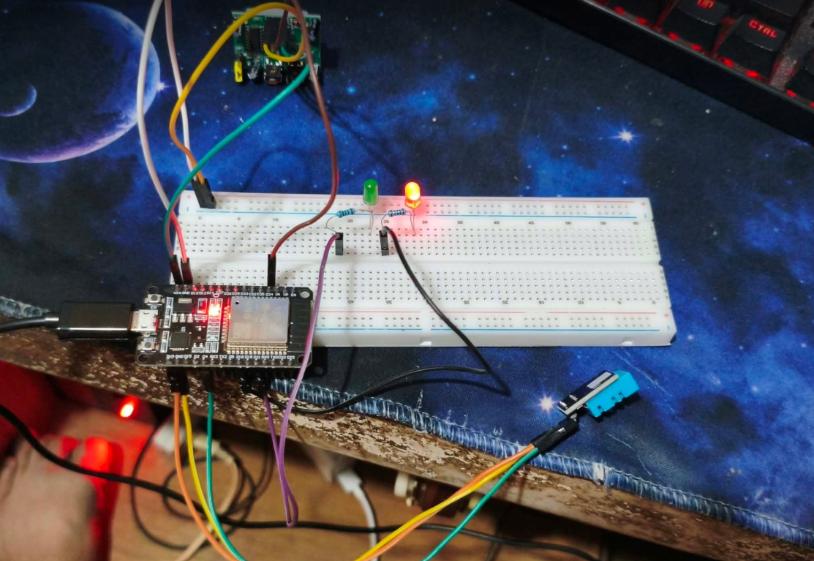
Figure B.1. Complete prototype
The photograph shows the breadboard assembly powered through USB. The red and built-in LEDs are illuminated. The built-in LED represents the PIR signal; the timed occupancy estimate is a separate state.
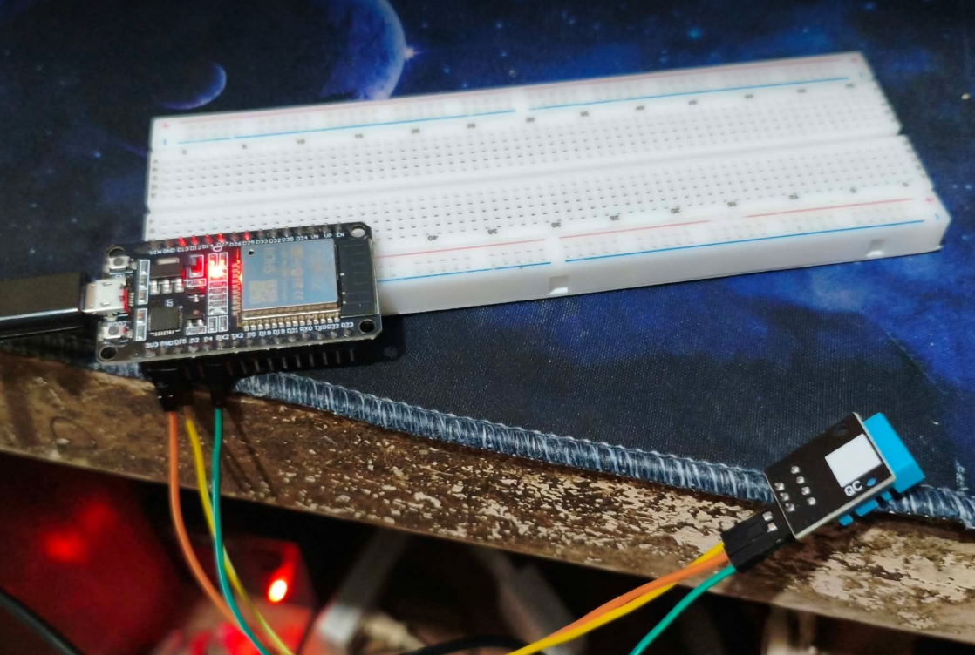
Figure B.2. DHT11 sensor connection
The DHT11 signal is connected to GPIO 4, with 3.3 V power and a common ground. Wiring establishes the measurement connection but does not independently establish sensor accuracy.
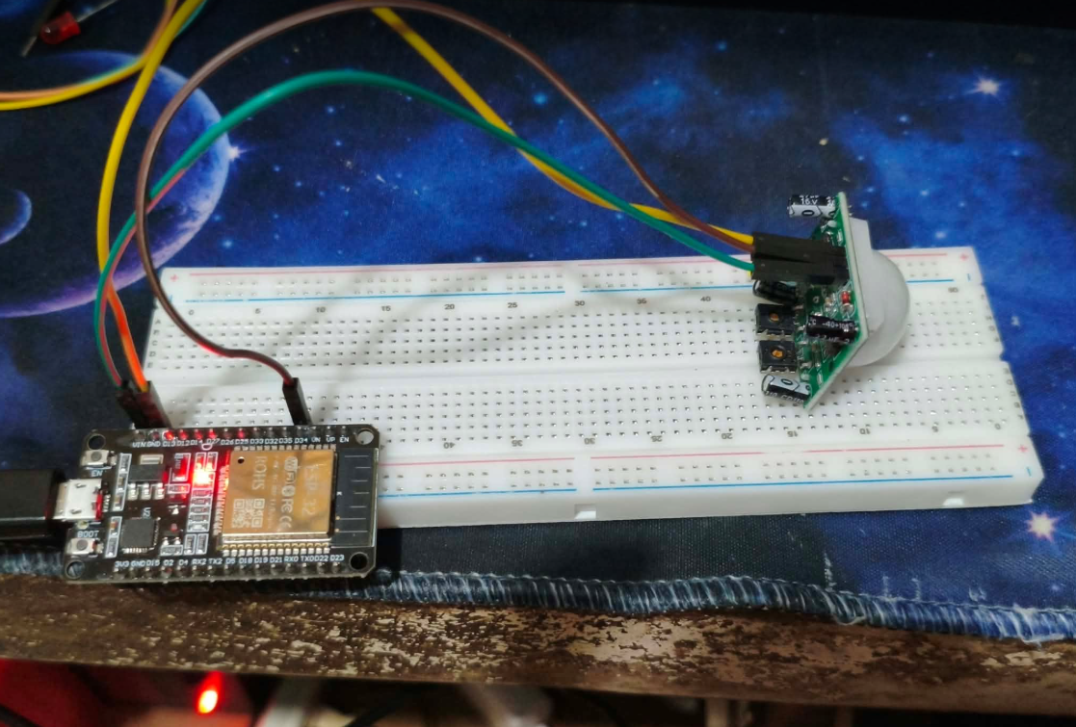
Figure B.3. PIR motion sensor connection
The HC-SR501 is connected to VIN, GND, and GPIO 34. Its output supplies the current motion signal used by the occupancy timer.
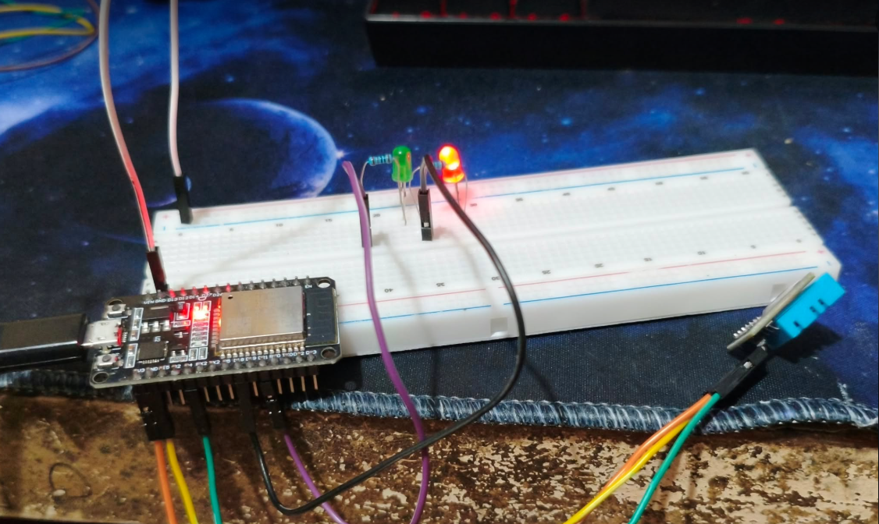
Figure B.4. Temperature LED indicators
The photograph documents the LED arrangement. A still image does not independently distinguish blinking from continuous illumination; the associated test record or log is needed.

Appendix C Illustrative Simulation Schematic
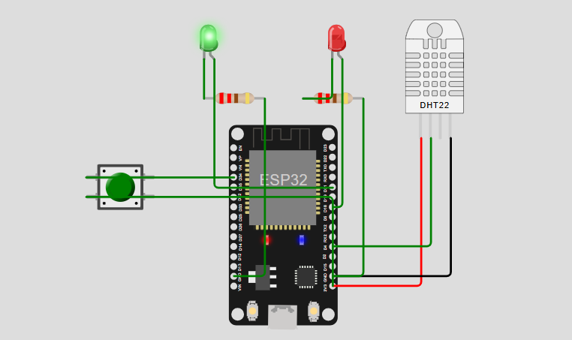
Figure C.1. Simulation schematic using substitute inputs
This original illustration uses a DHT22 in place of the physical DHT11 and a pushbutton in place of the HC-SR501 input. It is retained as an illustrative simulation schematic, not an exact wiring diagram of the completed prototype. The physical components and GPIO connections are specified in System Design. The illustration does not validate PIR behavior or occupancy accuracy.

Appendix D Serial Monitor Records
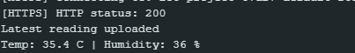
Figure D.1. Recorded temperature and humidity output
The supplied screenshot reports 35.4°C and 36% relative humidity. Under the project logic, temperature above 35°C determines the danger classification; humidity does not trigger this alert.
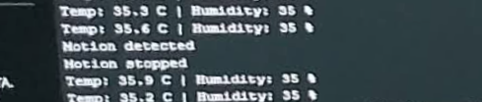
Figure D.2. Recorded motion transitions
The screenshot contains motion-detected and motion-stopped messages. These describe PIR signal transitions, not occupant counts or a ten-minute occupancy test. Updated occupancy transitions require separate logs and matching database records.

Appendix E Testing Records
Table E.1 retains the actual observations from the original test record. Expected behavior and result interpretations have been revised where necessary to match the updated firmware. An original observation is not rewritten to make it agree with the design.
Table E.1. Existing functional observations and revised interpretation
Trial and condition | Original actual observation
1 Normal temperature | Serial Monitor displayed 24.0°C / 50%. Green LED ON.
2 Motion detected | Built-in LED illuminated. Serial logged "Motion detected".
3 Motion stops | Built-in LED turned OFF. Serial logged "Motion stopped".
4 Warning temperature | Green OFF. Red blinked rapidly. Temp logged at 35.2°C.
5 Danger temperature | Green OFF. Red stayed solid. Temp logged at 35.3°C - 35.9°C.
6 DHT disconnect | LEDs OFF. Serial printed "DHT11 read failed".
Table E.1b. Expected behavior and interpretation of the original records
Trial | Expected behavior and result interpretation
1 | T ≤ 32°C: green on; red off. Reported pass; original record.
2 | PIR HIGH: motion LED on; detection transition. Reported motion response; occupancy timeout untested.
3 | PIR LOW: motion LED off; occupancy may remain likely occupied. Reported motion response; occupancy timeout untested.
4 | 32°C < T ≤ 35°C: green off; red toggles every 300 ms. Inconsistent at 35.2°C; retest required.
5 | T > 35°C: green off; red continuously on. Reported pass; original record.
6 | Sensor error; previous temperature LED condition retained. Before any valid reading: both off. Retest updated firmware; prior valid state unspecified.

E2 Software Verification Record
Table E.2. Software checks completed during the occupancy update
Check | Recorded result and scope
Type checking, linting, website build | Passed. Application consistency and production compilation.
Application logic tests | 6 passed. Includes occupancy handling for stale, legacy, and invalid records.
Firebase rule tests | 13 passed in the local emulator. Live rule deployment is not established by this result.
Occupancy state-machine assertions | Passed. Startup, 600 s boundary, timer renewal, continuous HIGH, unchanged states, and clock rollover.
Arduino compilation | Updated Downloads sketch and repository sketch both compiled successfully.
Authenticated dashboard inspection | Occupancy panel visible; older firmware without occupancy fields displayed unknown.

E3 Pending Physical Acceptance Tests
All rows below are planned tests. No new physical observations or pass results are asserted. Record the test date, firmware version, sensor placement and settings, trial count, event timestamps, and relevant screenshots when each test is performed.
Table E.3. Physical occupancy and connectivity acceptance matrix
Test condition | Expected behavior
Restart without motion | Unknown until motion occurs or the full initial ten-minute observation window elapses.
First motion signal | Likely occupied; occupancy transition queued and uploaded when available.
Motion stops before timeout | Current motion becomes idle; occupancy remains likely occupied.
Repeated or continuously HIGH input | Timer renews without duplicate unchanged occupancy transitions.
Ten minutes after the last HIGH signal | No recent activity transition; does not confirm vacancy.
Stationary occupant remains in the room | Compare estimate with observed presence; document missed occupancy if it expires.
Motion after inactivity | Likely occupied returns and a transition is recorded.
DHT failure while PIR works | Sensor-error heartbeat; invalid environmental values omitted; motion and occupancy continue.
Device Wi-Fi disconnected | Local logic continues; dashboard eventually reports stale/offline data and unknown occupancy.
Browser database connection lost | Connection status unavailable; current occupancy unknown.
Device power removed | Offline/unknown after freshness expires; previously uploaded history remains accessible.
Power removed before event upload | Pending events may be lost because the queue is volatile.
For threshold retesting, include exactly 32°C and 35°C and readings immediately above each boundary. Record the measured values and observed LED behavior without substituting expected values. Environmental accuracy testing requires a suitable reference instrument and a documented comparison procedure.

